 Final Year Project - UG
School of Computing Science and Engineering (SCOPE)
B.Tech. CSE/CPS/AL AND ML Capstone Project IN HOUSE

General Report (Sept 2022 – November 2022)

Program: B.Tech. CSE/CPS/AI AND ML Batch: 2019-2023 Course Code: CSE1904

Register No.: 19BAI109 Name of the Student: Arnab Karmakar Mobile No. 9721866757

Project Title:

STOCK MARKET PREDICTION USING MACHINE LEARNING

General Report (Sept 2022 – November 2022)

The financial exchange is one of the basic areas of a nation's economy. It permits financial backers to contribute and acquire profits from their venture. Foreseeing the securities exchange is an extremely difficult errand and has drawn in serious interest from specialists from many fields like measurements, man-made consciousness, financial matters, and money. An exact forecast of the financial exchange decreases speculation risk on the lookout. Various methodologies have been utilized to foresee the securities exchange. The exhibitions of Machine learning (ML) models are commonly better than those of measurable and econometric models. The brain network is one of the smart information mining procedures that has been involved by analysts in different regions for the beyond 10 years. Expectation and examination of financial exchange information play had a significant impact in the present economy. The different calculations utilized for gauging can be sorted into direct (AR, MA, ARIMA, ARMA) and non-straight models (ARCH, GARCH, Neural Network). Yet, this likewise intends that there's all's a ton of information to track down designs in. Thus, monetary investigators, specialists, and information researchers continue to investigate examination procedures to distinguish securities exchange patterns. This led to the idea of algorithmic exchanging, which utilizations computerized, pre-modified exchanging techniques to execute orders. I'll utilize both conventional quantitative money system and AI calculations to foresee stock developments. We'll go through the accompanying points:
Stock examination: major versus specialized investigation Stock costs as time-series information and related ideas Anticipating stock costs with Moving Average strategies Prologue to LSTMs
Foreseeing stock costs with a LSTM model Last considerations on new philosophies, like ES.

It has been observed that the stock market is very unpredictable therefore in greed of earning alpha so many people get bankrupt. Thus, we have to look for a few extra pieces of information that are affecting the stock price changes and can give a hint how the stock is going to perform in the future. The data set used for the project contains the information of promoter transactions that too precisely market buy and sell of stock transactions. We developed 11 models for the prediction that will help us in distinguishing which stocks to buy or not buy. The prediction was also done with creating the benchmarks like for 2 months holding period - 5% return benchmark
, 6 months holding period - 10% return benchmark, 9 month holding period - 13% return benchmark, and 12 month holding period - 15% benchmark. The predictions with benchmark will help the investors to earn Alpha. The results we were able to generate were more than satisfactory. We were able to make to a portfolio with average return of more than 100% in 12 months holding period.
Implementation | Patent / SCI / Scopus Indexed Journal Paper / Scopus Indexed Conference Paper/ Scopus  Indexed Book Chapter  This section of the project describes how the project will be implemented. This section consists of web scraping, data preparation, data mining, and algorithm development.  Web scraping played a really important role in the preparation of the data as every data was not present in a single place and since for this project we prepared our own data, thus collecting the data from different sites about the stock is really difficult if not web scraping.  Since we are predicting whether the stock is going to provide us profit in the future if we are investing in it or not, we have to get a little extra information about all the stocks. Every stock registered with NSE (National Stock Exchange) has a stock code or token a unique code for them to uniquely identify them thus we need to have those in our dataset as the data which we download from the NSE site doesn’t consist it.  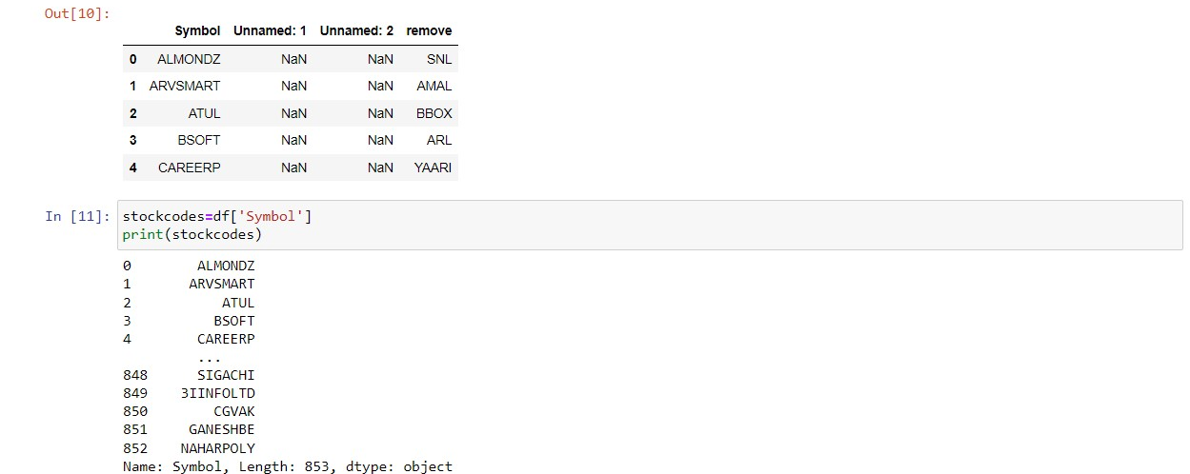  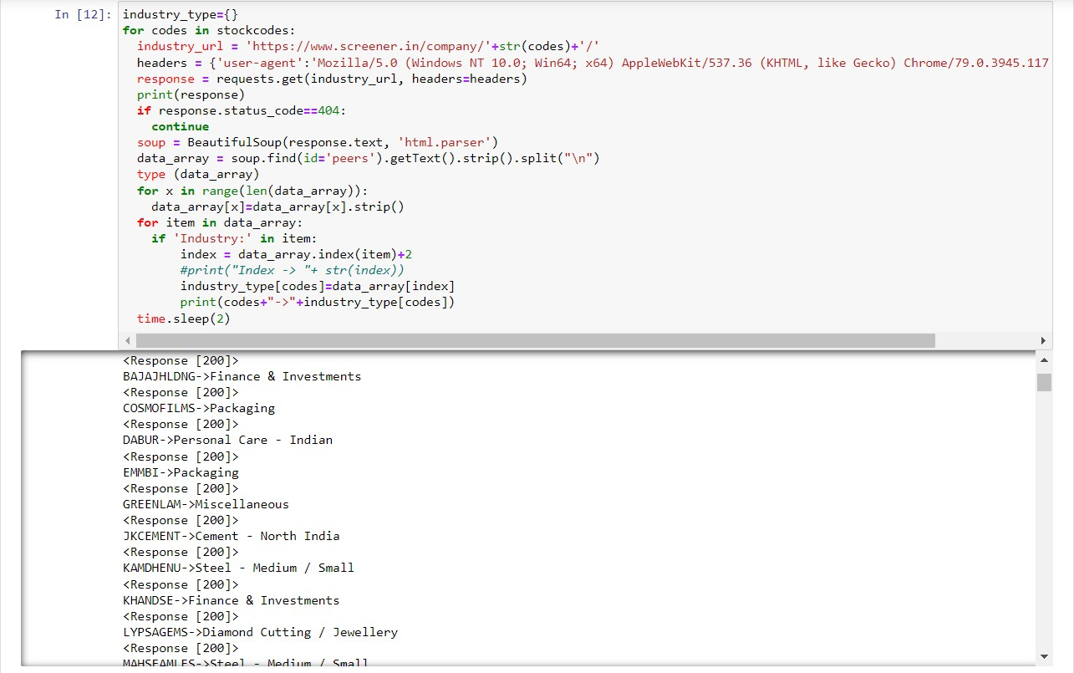  _____________________________________________________________________________
Work Status | Excellent / Good / Satisfactory / Needs improve
Attendance Status | Regular / Irregular | CAM – Max. 5 Marks per week

Arnab Karmakar (19BAI1090)

Signature of the Student with date Name & Signature of the Guide with date



